# Media Analysis - AI is not smarter than humans _ Updated 08 April 2023

## Short Summary

The article discusses the advancements and potential of artificial intelligence AI , particularly in marketing and personal assistance tasks.

## Summary

•AI's role in personal life & business tasks  
•Examples like Siri and AI-powered recruitment tools  
•Importance of engineers in developing smooth AI technology  
•Balancing AI assistance with human connection and uniqueness

## Question 1

The media, particularly when discussing AI tools like ChatGPT, can frame public discussions in various ways. These frames often highlight novelty, potential benefits and risks, as well as ethical considerations. Metaphors play a significant role in how journalists and the general public articulate their thoughts about these AI technologies. For example, ChatGPT might be described as a thinking machine or a language genie. These metaphors evoke emotions, create vivid images, and shape public perceptions. Overall, the media s framing of discussions about ChatGPT and similar AI tools is dynamic and shaped by various factors including evolving technology, public sentiment, and expert opinions.

## Question 2

The text discusses AI from various perspectives, including 1. Advancements and applications AI as a tool for simplifying tasks, generating innovative ideas, and improving marketing campaigns. 2. Human connection vs automation The emphasis on AI not replacing human connections and personalized interactions. 3. Language translation and cross-cultural understanding Google Translate and its impact on global communication. 4. Elderly perspectives The text includes a conversation with an elderly person about the technology, highlighting their unique perspective. Aspects being ignored or less emphasized in the text might include - Ethical considerations in AI development and deployment. - The potential for AI to exacerbate existing social inequalities. - Challenges faced by businesses and individuals adapting to AI integration. - Long-term implications of AI on job displacement and the economy.

## Question 3

Not mentioned.

## Question 4

The final message is that AI can enhance our lives, but it cannot replace human connection and its personal touch.

## Sentiment

The sentiment is -5.0

## Entities

Microsoft, Saleh, Tay, SAP, Oracle, Google Translate, Ali Al-Mustafa, Saint Marys University, Twitter, Apple

## Highlights

#7cc867#fb5b89#f9cd59

## Wordcloud for #7cc867 Highlights

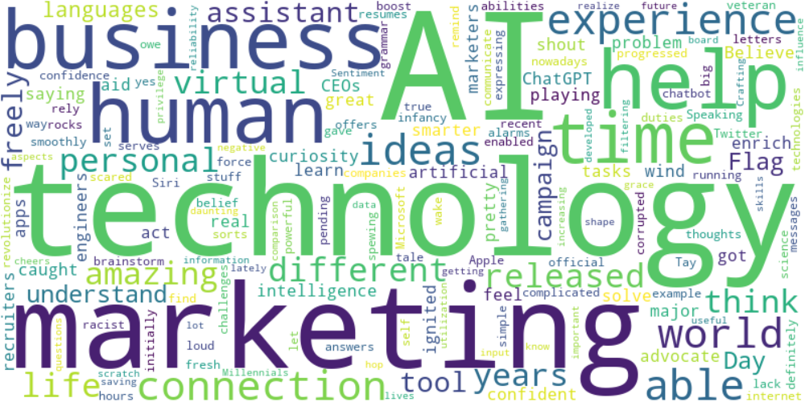

Top 10 words:

- AI: 10

- technology: 8

- marketing: 6

- like: 5

- business: 4

- humans: 3

- experience: 3

- able: 3

- ideas: 3

- connection: 3

## Wordcloud for #fb5b89 Highlights

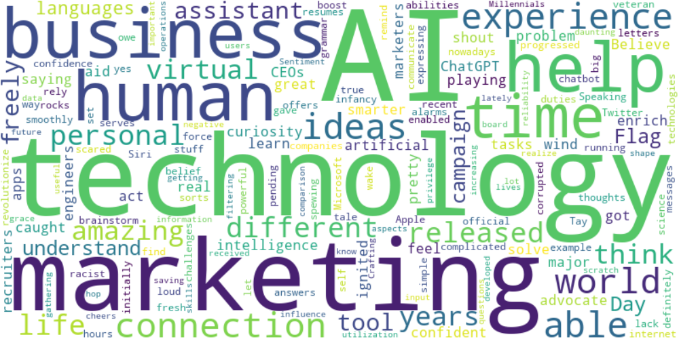

Top 10 words:

- AI: 10

- technology: 8

- marketing: 6

- like: 5

- business: 4

- humans: 3

- experience: 3

- able: 3

- ideas: 3

- connection: 3

## Wordcloud for #f9cd59 Highlights

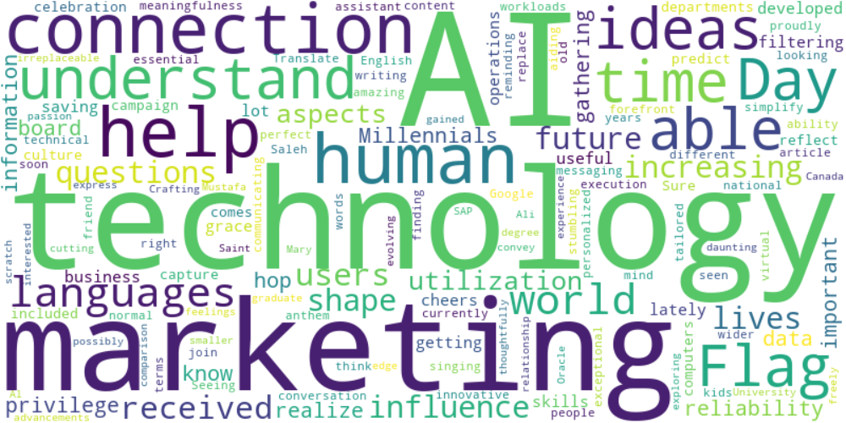

Top 10 words:

- AI: 6

- technology: 5

- marketing: 4

- connection: 3

- help: 3

- like: 2

- humans: 2

- understand: 2

- able: 2

- ideas: 2